11.91: The normal component of the force is 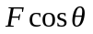 and the area (the intersection of the red plane and the bar in Figure (11.52)) is 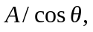 so the normal stress is 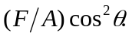
b) The tangential component of the force is 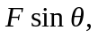 so the shear stress is 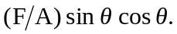
c) 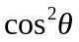is a maximum when 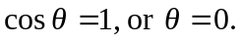 d) The shear stress can be expressed as 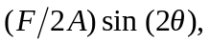which is maximized when 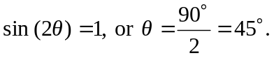 Differentiation of the original expression with respect to and setting the derivative equal to zero gives the same result.

